

**TWEB333 Advance Web Design**

**Assignment Report**

**Group Member:**

**YAN YONG KANG (2050263-DWD)**

**SIEW TIAN CHENG (2050319-DWD)**

**YU KAI YANG (2120102-DWD)**

**Lecturer:**

**MR. LAW TENG YI**

Table of Contents

Contribution 3

Design page 4

Layout Page 8

JSON 26

Jquery plugin 27

Conclusion 28

# Contribution

|  |  |  |
| --- | --- | --- |
| **Name** | **Job** | **Description** |
| Yan Yong Kang | Founder | * Found template on Internet * Meeting and discussion with teacher * Edit code (header, footer, Multiscroll.js) |
| Siew Tian Cheng | Designer | * Edit code (shop, contact us, Checkout.js) |
| Yu Kai Yang | Designer | * Edit code (index, Flickerplate.js) * Report discussion |

# Design page

Index

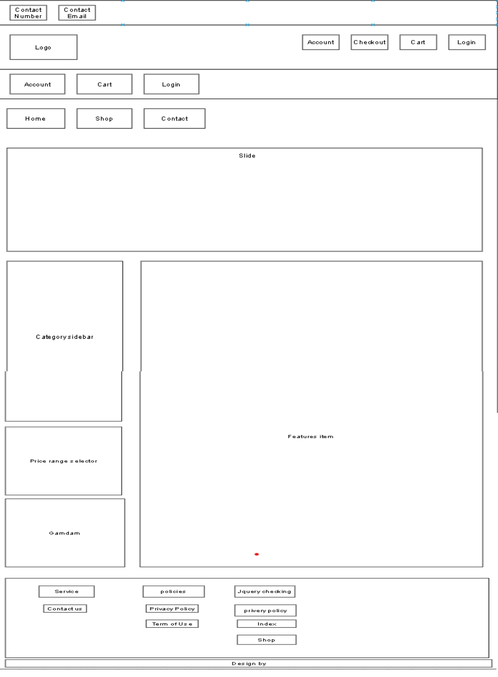

Checkout

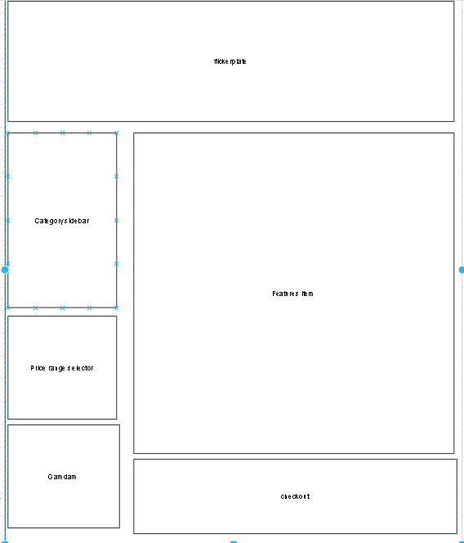

Product Details

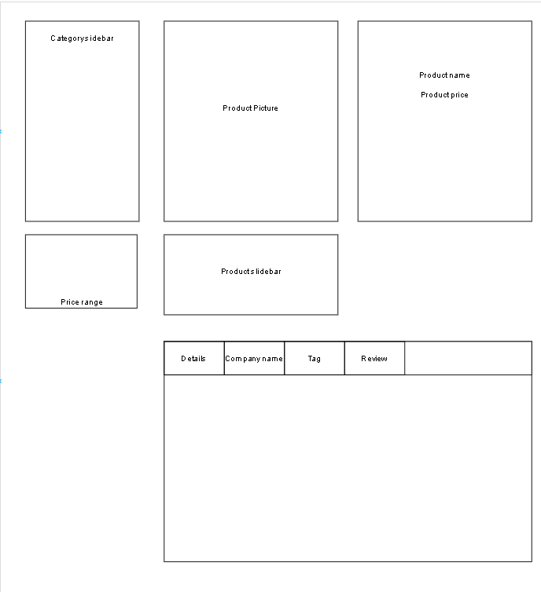

Contact Us

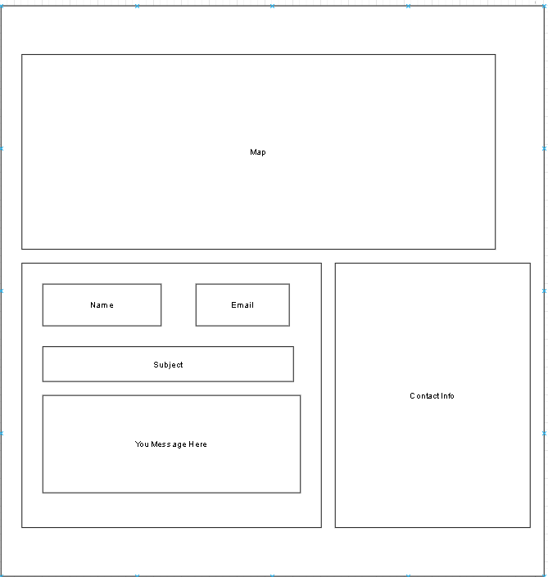

# Layout Page

Index

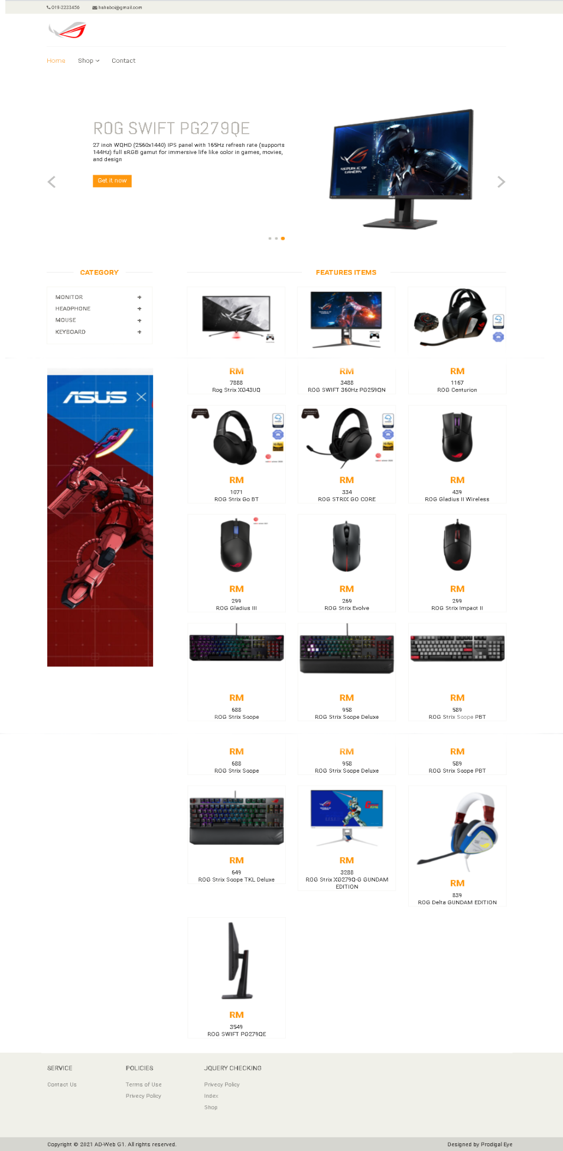

Shop

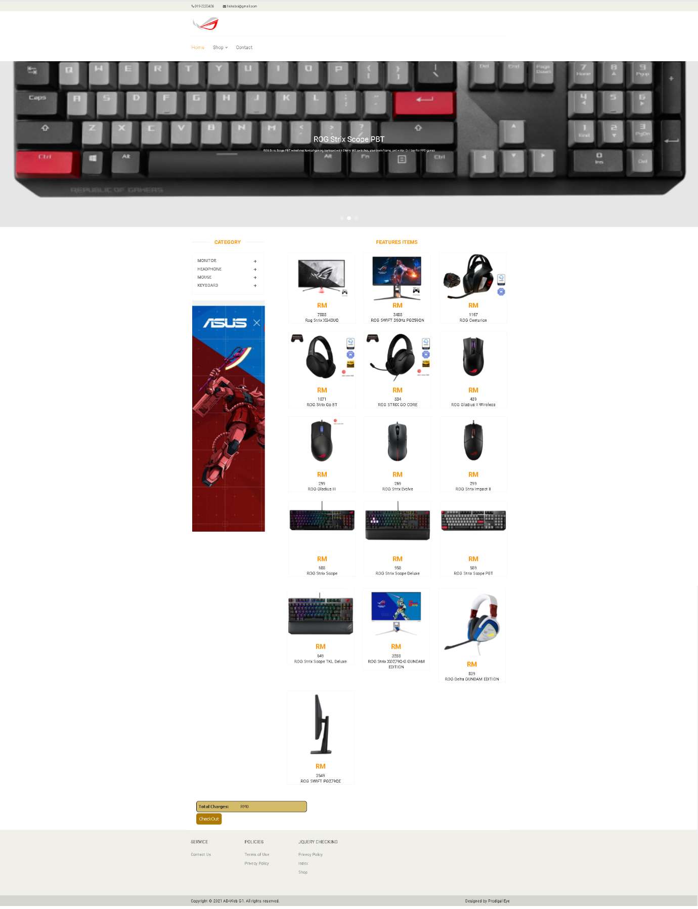

Product detail

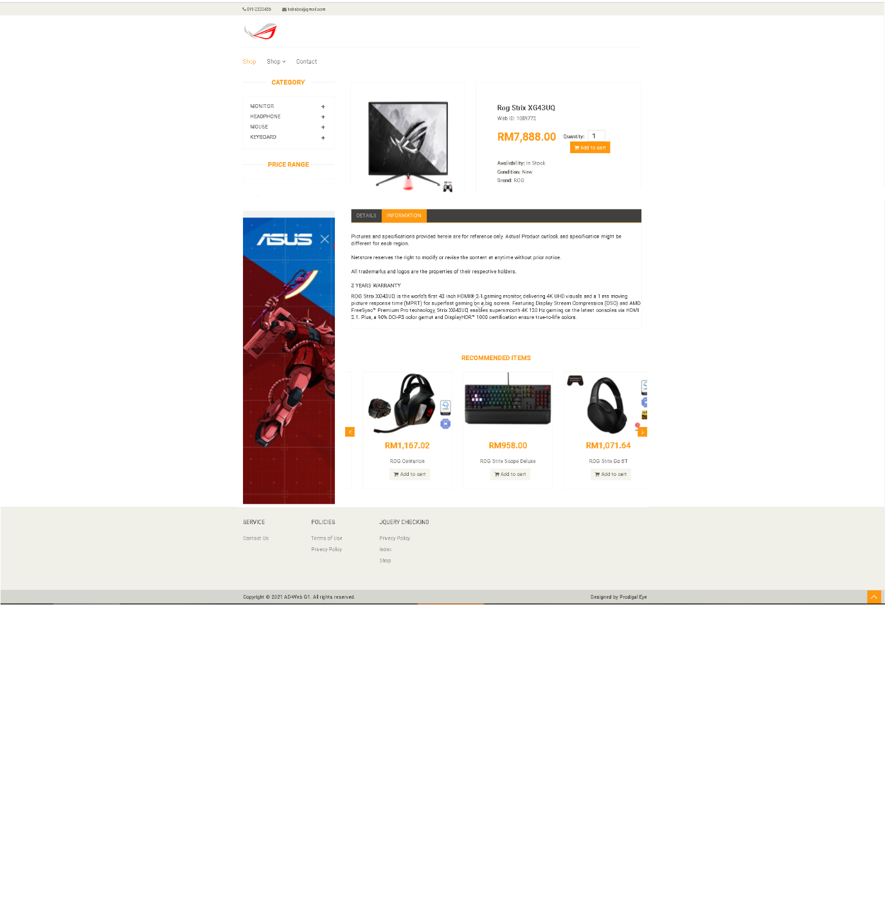

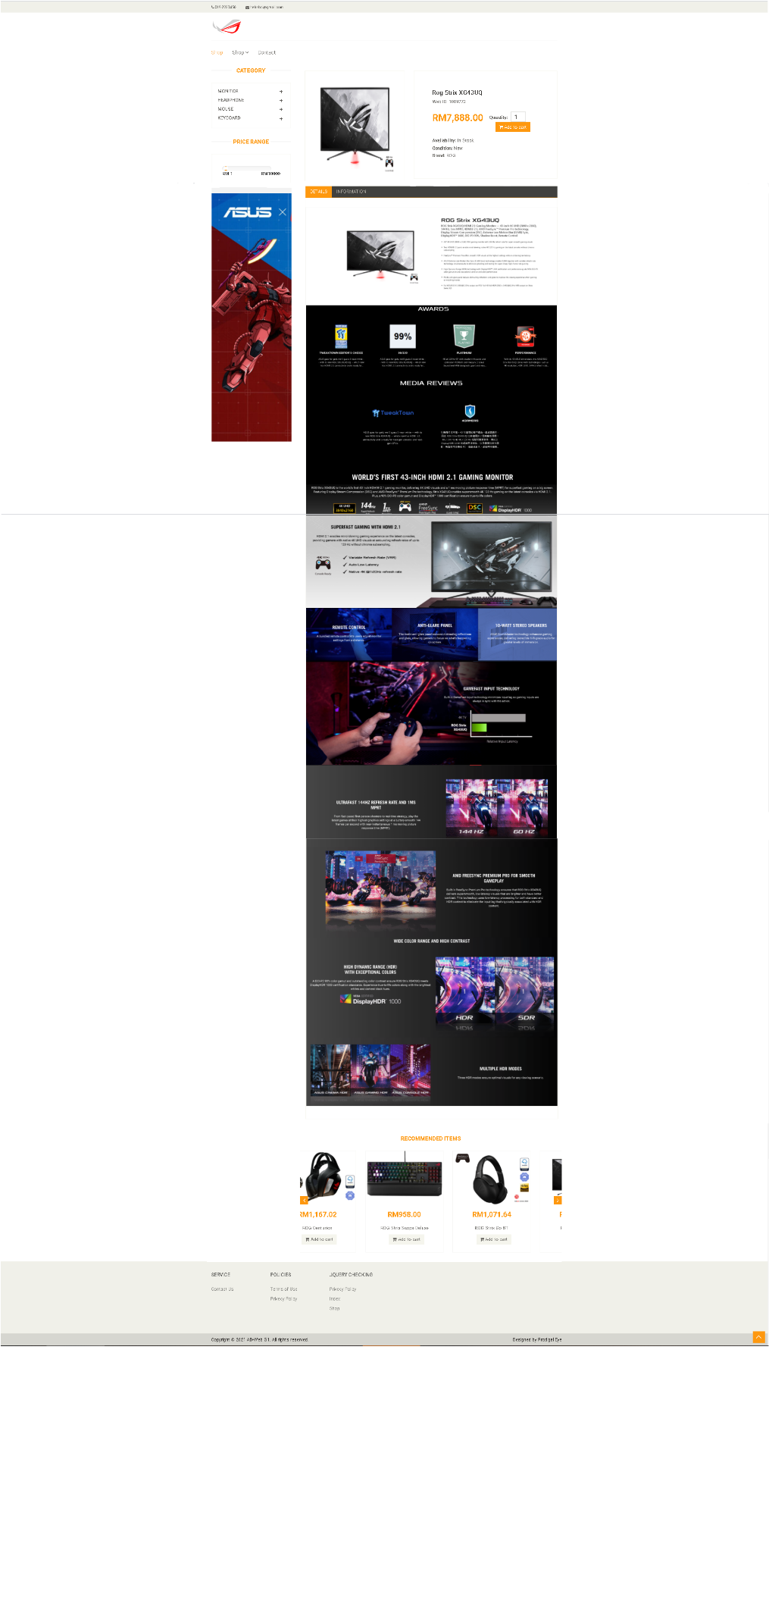

Contact

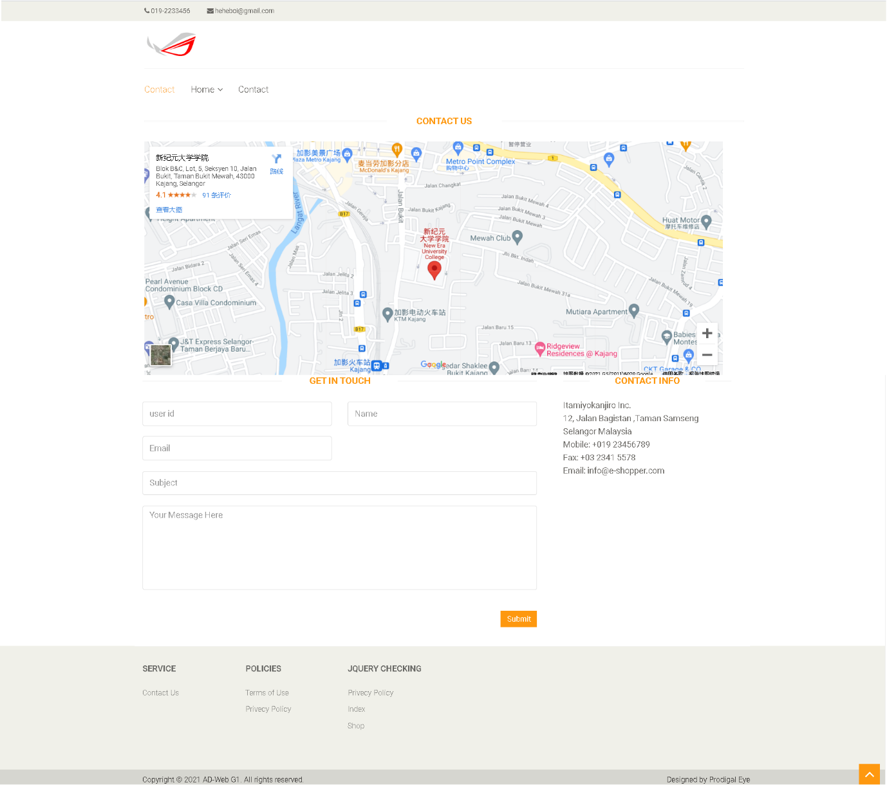

Privacy policy

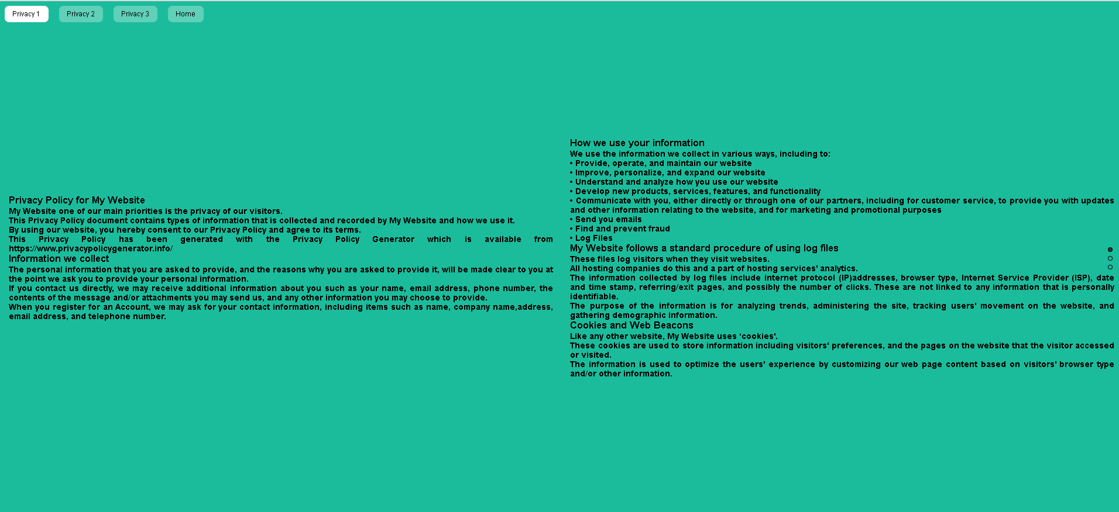

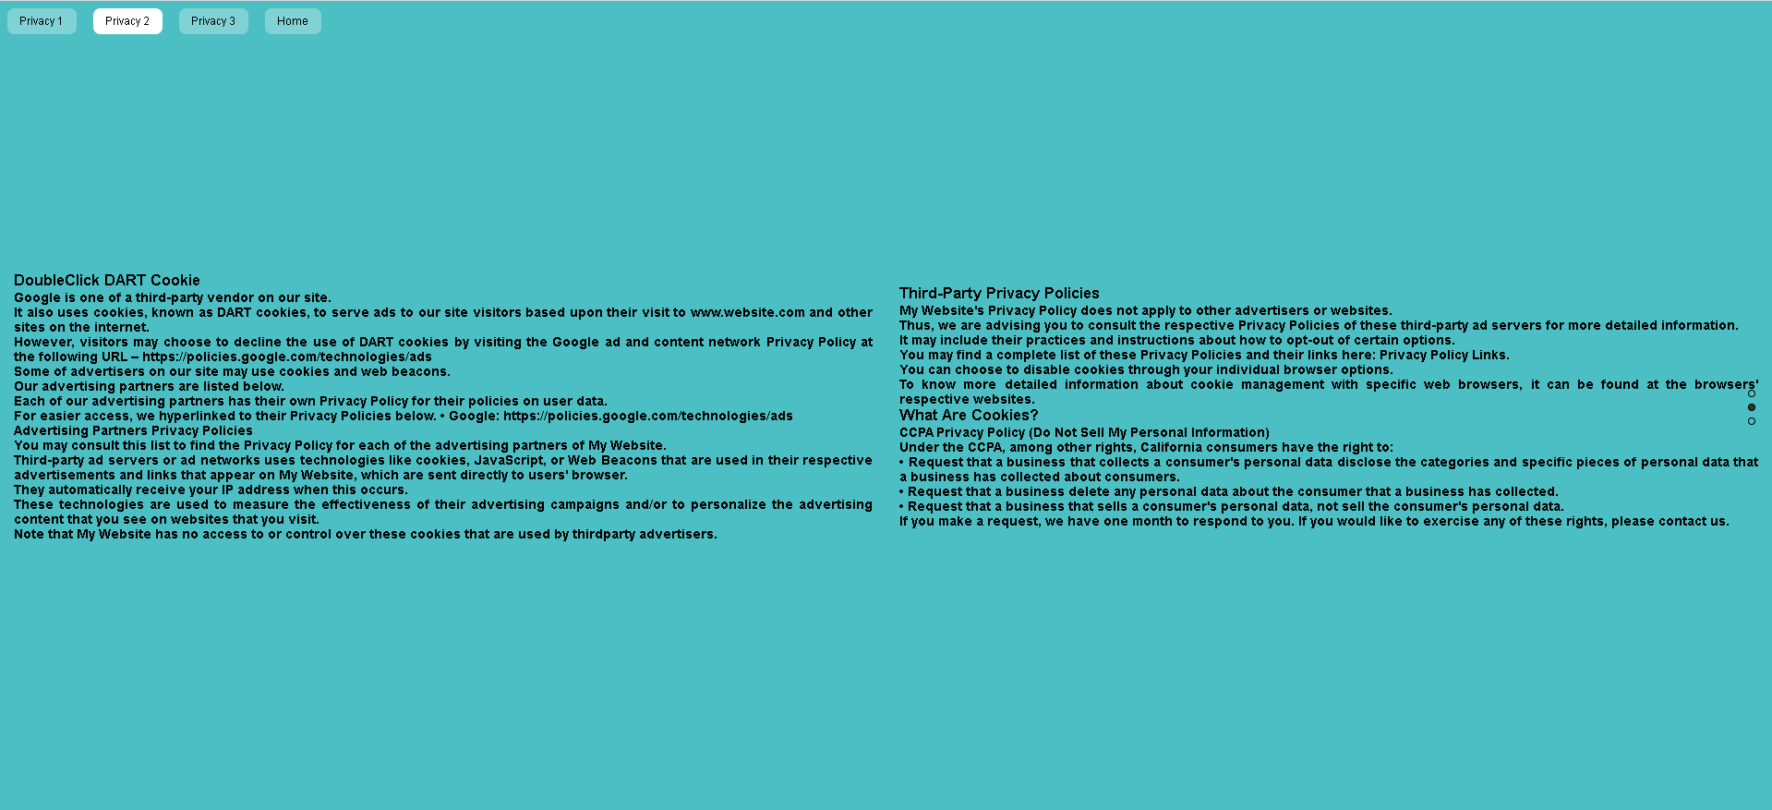



Headphone display

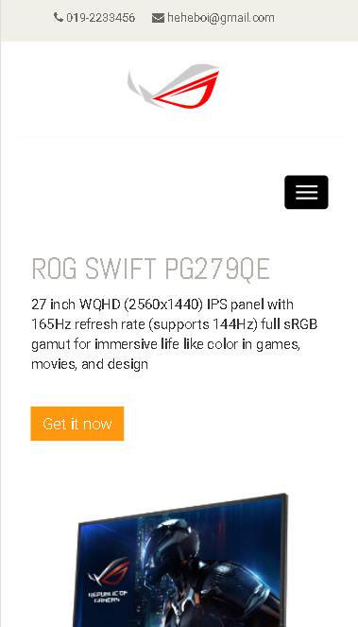

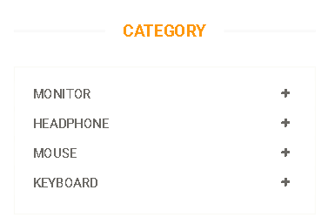

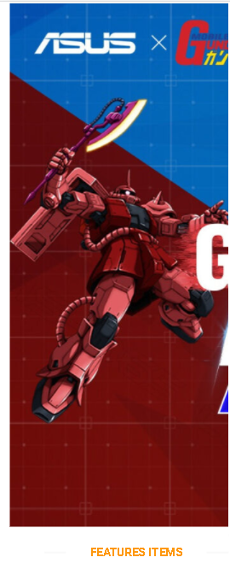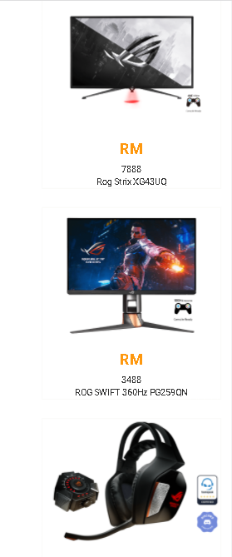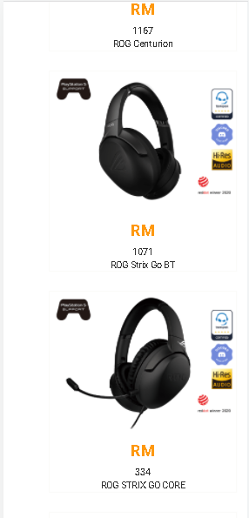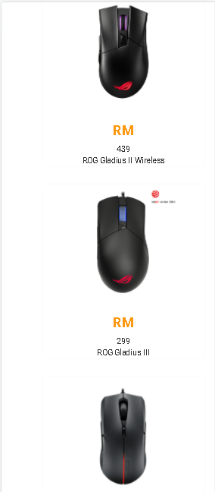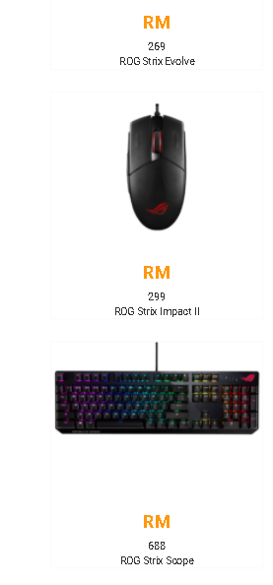

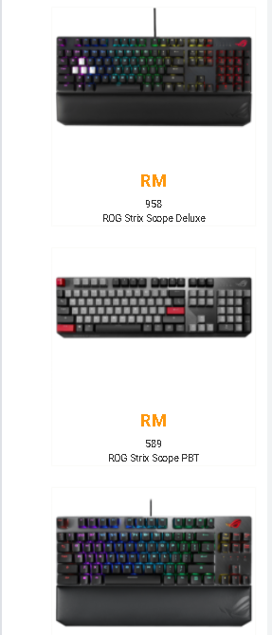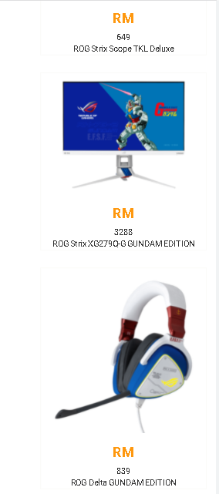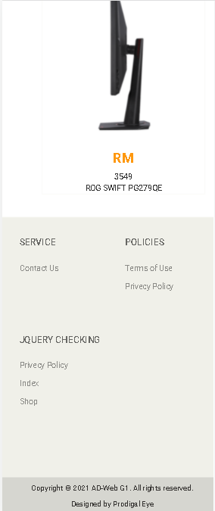

Shop

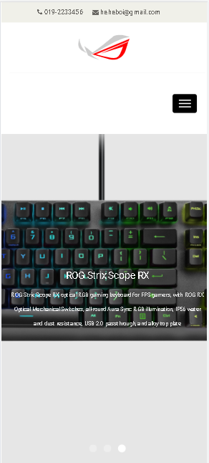





Product detail



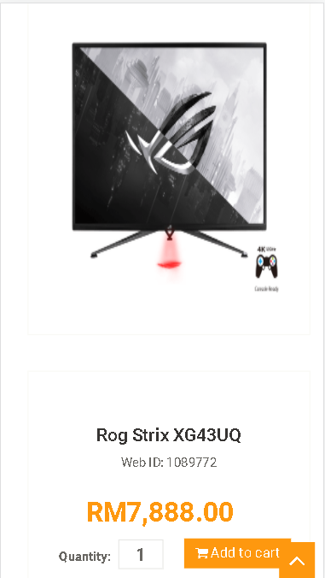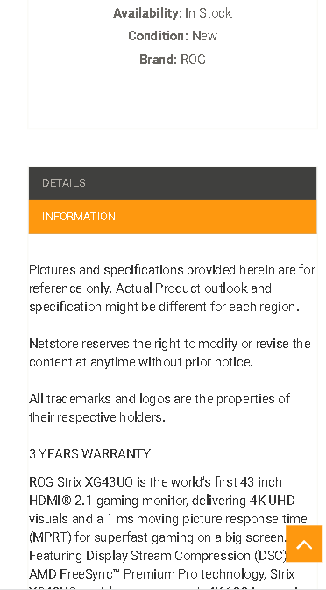

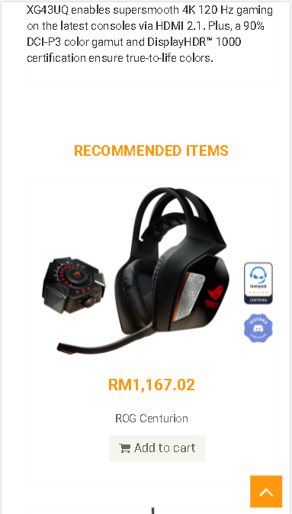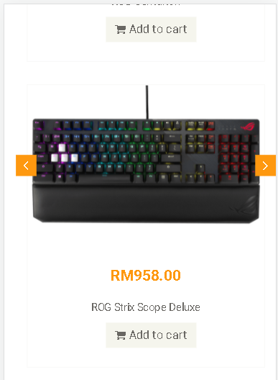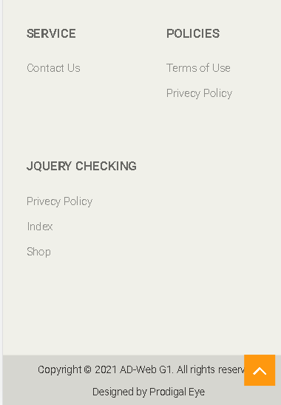

Contact us





Privacy policy



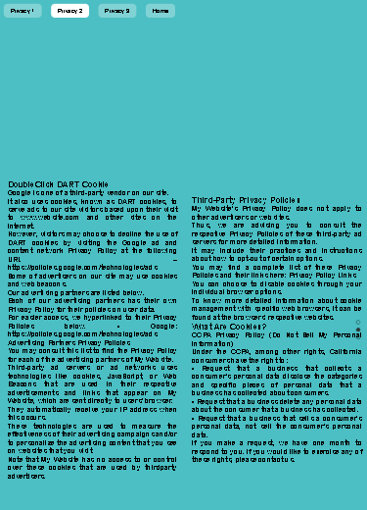

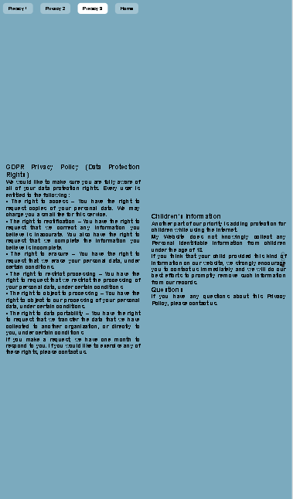

# JSON

[

{

"id": "1",

"name": "qwe",

"email": "qwe@gmail.com",

"subject": "qweqwewqewqewqeqw",

"message": "asd"

}

]

# Jquery plugin

The jquery plugins that I decided to use in our group has Checkout.js, Slideshow.js, Slidebar.js, and Rowgrid.js. Since we decided to use another jquery plugins later is Checkout.js, Multiscroll.js, Flickerplate.js because other plugins not suitable so we change.

About the plugin Checkout.js, is our teammate Siew Tian Cheng in charge. The problem he encountered is that the understanding in coding is too shallow, and it is easy to encounter bottlenecks. He went to the teacher to ask about the problem, so that he could solve his problem.

The plugin of Multiscroll.js is charge by Yan Yong Kang. He encountered more difficulties, because he knew less about coding, so he would be stuck more or less. In the end, he relied on the help of friends to solve the problems.

And the last plugin, Flickerplate.js, is charge by Yu Kai Yang. He is the student with the least knowledge of coding in this team, so he does something simpler than other team members, of course, there are times when he doesn't. It is also to let other team members help him.

# Conclusion

Technology has made significant progress over the years to provide consumers a better online shopping experience and will continue to do so for years to come. With the rapid growth of products and brands, people have speculated that online shopping will overtake in-store shopping.

References

1. <https://rog.asus.com/my/mice-mouse-pads-group/>
2. <https://rog.asus.com/my/headsets-audio-group/>
3. <https://rog.asus.com/my/keyboards-group/>
4. <https://rog.asus.com/my/monitors-group/>

Template

<https://www.free-css.com/free-css-templates/page203/e-shopper>

GitHub

<https://github.com/yongkang2050/alex-law-project>

Website URL

<http://prodigaleyedemo.great-site.net/>